**Synthesis and Characterization of Isatin Derivatives: Mannich Base and its Corresponding Schiff Base, Sulfone and Sulfoxide.**

**Course Title: Research Project, Course Code: CH 466**



**A**

**Project Paper**

**Submitted to the Department of Chemistry in Partial Fulfillment of the Requirements for the Bachelor of Science Degree in Chemistry.**

**Submitted By**

**Md. Shahriar Labib**

**Exam Roll: CHE 021/4**

**Session: 2020-2021**

**Registration No: 151-051-18**

**January, 2024**

**Department of Chemistry**

**University of Barishal**

**Kornokathi, Barishal 8254**

Abstract

Above all, I express my utmost gratitude to the Almighty Allah for His abundant blessings that guided me through my research, enabling the successful completion of the research project.

I would like to express my sincere gratitude to all those who have contributed to the successful completion of this research project. This work would not have been possible without the support, guidance, and encouragement from various individuals and institutions.

1 Introduction 4

1.1 General Remarks 4

1.2 Objective of Research 4

2 Review of Literature 5

2.1 Previous Research on Isatin-Derived Compounds 5

2.2 Significance of the Current Study 5

3 Synthesis 6

3.1 Synthesis of Mannich Base (RN-1) 6

4 Results and Discussion 7

4.1 Mannich Base Synthesis (RN-1) 7

5 Applications 8

6 Conclusion 9

7 References 10

Table of Figures

Figure 1: Formation of Mannich Base 7

Figure 2: RN-1 8

Figure 3: Application of compounds. 9

# Introduction

## General Remarks

is a protean compound (presence of lactam and keto moiety permits to change its molecular framework) is a synthetically versatile substrate, which can be used for the synthesis of a large variety of heterocyclic compounds, such as indoles and quinolines, and precursors for drug synthesis. It is a promising class of biologically active scaffolds with tolerance to humans [1] and a good platform for structure modification and derivatization. Isatin derivatives display a myriad of activities including anticancer [2], antidepressant [3], antifungal [4], anti-HIV [5], and anti-inflammatory [6] properties. Isatin is a naturally occurring heterocyclic compound that can be found in plants of the genus *Isatis* and also in humans.

## Objective of Research

The primary objective of this research is to systematically investigate and elucidate the synthetic pathways leading to Mannich bases, Schiff bases, sulfones, and sulfoxides derived from isatin. By undertaking a comprehensive exploration of these transformations, the study aims to achieve the following specific goals.

# Review of Literature

## Previous Research on Isatin-Derived Compounds

The exploration of isatin derivatives in previous research has laid a solid foundation for understanding their synthetic accessibility and diverse chemical reactivity. Early studies focused on fundamental methodologies involving the condensation of isatin with various nucleophiles, leading to the formation of substituted isatins. These derivatives have been investigated for their unique chemical properties and potential applications.

## Significance of the Current Study

Building upon the established knowledge base, the current study holds significance in several key aspects. Firstly, it aims to expand the repertoire of isatin-derived compounds by synthesizing sulfones, sulfoxides, Mannich bases, and Schiff bases. This approach brings forth the opportunity to explore the structural diversity and potential applications of these derivatives, complementing and extending the findings of previous research.

# Synthesis

## Synthesis of Mannich Base (RN-1)

According to research paper [7], for the synthesis of RN-1, 1 gram of isatin was combined with 0.6 ml of morpholine in a 1:1 molar ratio, dissolved in 20 ml of methanol. Following this, 1.5 ml of formaldehyde were introduced into the mixture, which underwent reflux at 100℃ for 3.5 hours. Afterward, the reaction mixture was refrigerated overnight. Some solvent was removed using a rotary evaporator. The resulting crystals were filtered and subjected to recrystallization with methanol to purify the product. The purified product was obtained, and its weight corresponded to a calculated yield of 70.07%.



Figure : Formation of Mannich Base

# Results and Discussion

## Mannich Base Synthesis (RN-1)

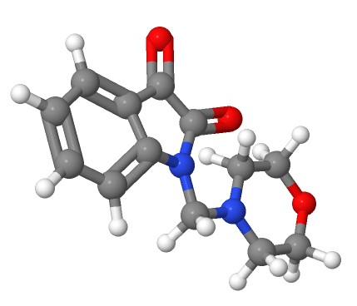The Mannich base (RN-1) was successfully synthesized through the reflux reaction of isatin and morpholine in methanol, facilitated by formaldehyde. The reaction proceeded for 3.5 hours at 100°C, resulting in a refined product with a satisfactory yield of 70.07%. The use of methanol as a solvent and recrystallization contributed to the purification of RN-1.

Figure : RN-1

# Applications

Recent studies highlight promising hydrazine-linked morpholinated isatin–quinoline hybrids as effective and safer anti-breast cancer agents. These hybrids demonstrated notable efficacy against two breast cancer cell lines, MCF-7 and MDA-MB-231, showcasing the potential of combining isatin and morpholine derivatives for therapeutic advancements in breast cancer treatment.

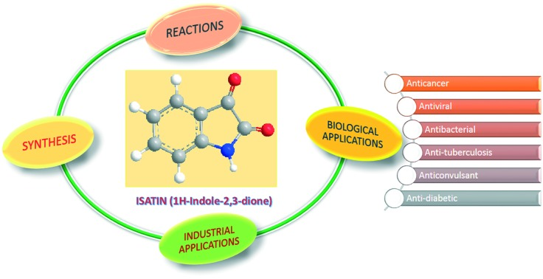

Figure : Application of compounds.

# Conclusion

In the pursuit of synthesizing isatin-derived compounds, this research has unveiled both successes and challenges, offering valuable insights into the intricacies of the synthetic process. The successful synthesis of Mannich base (RN-1) from isatin and its subsequent conversion to Schiff base (RN-2) underscore the versatility of isatin as a foundational platform for crafting diverse nitrogen-containing compounds. These accomplishments highlight the potential for leveraging isatin as a key building block in the creation of structurally intricate molecules.

# References

|  |  |
| --- | --- |
| [1] | G. Wang, M. Chen, J. Qiu, Z. Xie and A. Cao, "Synthesis, in vitro α-glucosidase inhibitory activity and docking studies of novel chromone-isatin derivatives," *Bioorganic & Medicinal Chemistry Letters,* vol. 18, no. 2, pp. 113-116, 2018. |
| [2] | H. S. Ibrahim, S. M. Abou-Seri, M. Tanc, M. M. Elaasser, H. A. Abdel-Aziz and C. T. Supuran, "Isatin-pyrazole benzenesulfonamide hybrids potently inhibit tumor-associated carbonic anhydrase isoforms IX and XII," *European Journal of Medicinal Chemistry,,* vol. 103, pp. 583-593, 2015. |
| [3] | X.-M. Zhang, H. Guo, Z.-S. Li, F.-H. Song, W.-M. Wang, H.-Q. Dai, L.-X. Zhang and J.-G. Wang, "Synthesis and evaluation of isatin-β-thiosemicarbazones as novel agents against antibiotic-resistant Gram-positive bacterial species," *European Journal of Medicinal Chemistry,* vol. 101, pp. 419-430, 2015. |
| [4] | N. D. Thanh, N. T. K. Giang, T. H. Quyen, D. T. Huong and V. N. Toan, "Synthesis and evaluation of in vivo antioxidant, in vitro antibacterial, MRSA and antifungal activity of novel substituted isatin N-(2,3,4,6-tetra-O-acetyl-β-d-glucopyranosyl)thiosemicarbazones," *European Journal of Medicinal Chemistry,* vol. 123, pp. 532-543, 2016. |
| [5] | B. A. P. Y. D. S. Tanushree Ratan Bal, "Synthesis and evaluation of anti-HIV activity of isatin β-thiosemicarbazone derivatives," *Bioorganic & Medicinal Chemistry Letters,* vol. 15, no. 10, pp. 4451-4455, 2005. |
| [6] | Z. Xu, S. Zhang, C. Gao, F. Zhao, Z.-S. Lv and L.-S. Feng, "Isatin hybrids and their anti-tuberculosis activity," *Chinese Chemical Letters,* vol. 28, no. 2, pp. 159-167, 2017. |

|  |  |
| --- | --- |
| [7] | H. Bagum, M. A. Hossain, M. AL-AMIN and M. R. Islam, "SYNTHESIS AND CHARACTERIZATION OF A SERIES OF MANNICH BASES AS CYTOTOXIC AGENTS," *Journal of Bangladesh Chemical Society,* vol. 26, no. 1, pp. 93-99, 2013. |
| [8] | A. Singh, H. Kaur, S. Arora and P. M. S. Bedi, "Design, synthesis, and biological evaluation of novel morpholinated isatin–quinoline hybrids as potent anti-breast cancer agents.," *Archiv der Pharmazie,* vol. 355, no. 2, 2022. |